Project 1
Yu SU 55323707
1.
17.2.4
Subset size | Attributes in best subset | Classification accuracy
9 | Si Al Ba Mg Na Ca Ri K Type | 77.1028
8 | Al Ba Mg Na Ca Ri K Type | 77.5701
7 | Ba Mg Na Ca Ri K Type | 78.972
6 | Mg Na Ca Ri K Type | 78.0374
5 | Na Ca Ri K Type | 77.1028
4 | Ca Ri K Type | 73.8318
3 | Ri K Type | 64.9553
2 | K Type | 49.0654
1 | Type | 35.514
0

17.2.5
No, it is not an unbiased estimate of accuracy on future data. For each attribute selection step, if we only use the data in each fold to make choice is OK, but we actually use(look) the whole test set to make choice, which will cause the overfitting (make the accuracy looks better than it should be)

2.
The right way is before the cross-validation, we should leave one of the folds out as the final test set. And then do the execution of 17.2.4 on the other folds. After we get the best subsets, we could use the left test fold to test the classification accuracy of these subsets. This accuracy is the final unbiased estimate of accuracy on future data.

3.
17.4.8
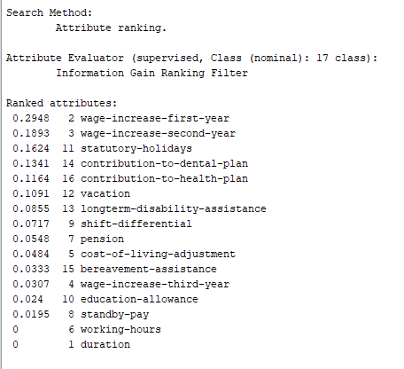

Four most important attribute:
2 wage-increase-first-year
3 wag-increase-second-year
11 statutory-holidays
14 contribution-to-dental-plan

17.4.9
CfsSubsetEval/BestFirst:

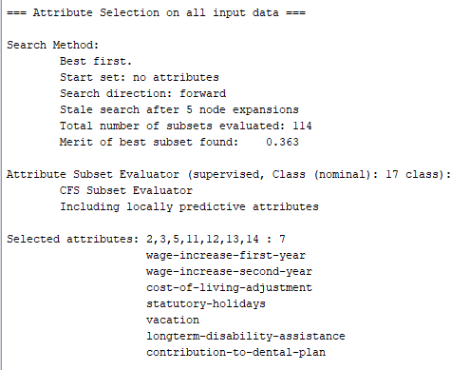
J48/BestFirst:

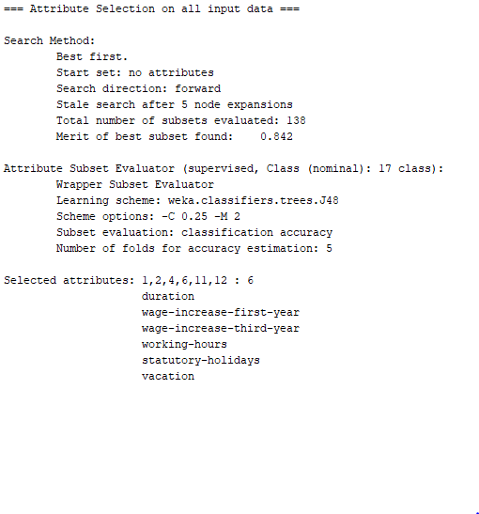
The attributes are selected by both methods:
2 wage-increase-first-year
11 statutory-holidays
12 vacation

Relate to ranker:
The rank of these three attributes is 1,3,6. That means in different algorithm the best attributes are not same. CfsSubsetEval focus on relation and the infogain focus on individual information gain.

17.4.10
Number of copies | accuracy | Selected attribute
0 | 75.5208% | 2,6,7,8
1 | 75.5208% | 2,6,7,8
2 | 75.5208% | 2,6,7,8
3 | 75.5208% | 2,6,7,8
4 | 75.5208% | 2,6,7,8

No matter how many redundant copies in the data, the accuracy is always same, so we could say the NaiveBayes could eliminate the redundant attributes.

17.4.11
Accuracy:
Number of copies | BestFirst/wrapper | BestFirst/CfsSubset | Ranker/infogain
0 | 73.9583% | 75.5208% | 74.349%
1 | 73.9583% | 75.5208% | 74.0885%
2 | 73.9583% | 75.5208% | 73.4375%
3 | 73.9583% | 75.5208% | 72.0052%
44 | 73.9583% | 75.5208% | 72.0052%

Selected attributes
Number of copies | Bestfirst/wrapper | BestFirst/CfsSubset | Ranker/infogain
0 | 1,2,3,6,7 : 5 | 2,6,7,8:4 | 2,6,8,5,4,1,7,3:8
1 | 1,2,3,6,7 : 5 | 2,6,7,8:4 | 2,6,8,5,4,10,1,7:8
2 | 1,2,3,6,7 : 5 | 2,6,7,8:4 | 2,6,8,5,4,11,10,1 :8
3 | 1,2,3,6,7 : 5 | 2,6,7,8:4 | 2,6,8,5,4,12,11,10:8
4 | 1,2,3,6,7 : 5 | 2,6,7,8:4 | 2,6,8,5,4,12,13,1 :8

First two methods could eliminate the redundant attribute because their result does not change when there are new copy in the data.
While the method of ranker could not eliminate the redundancy. The copy will influence the result, because the ranker method focuses on individual single information gain of each data. There in no relation between each attribute, so it can not eliminate the redundancy.

17.4.12
Optimized:
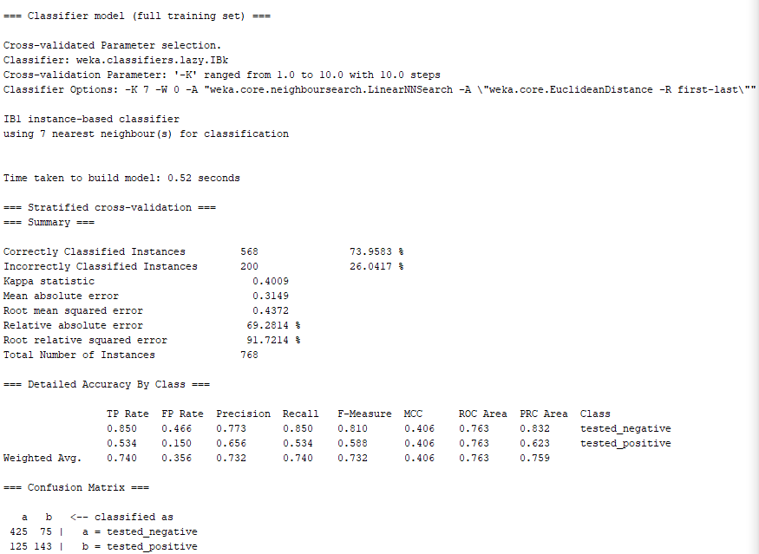
Original:
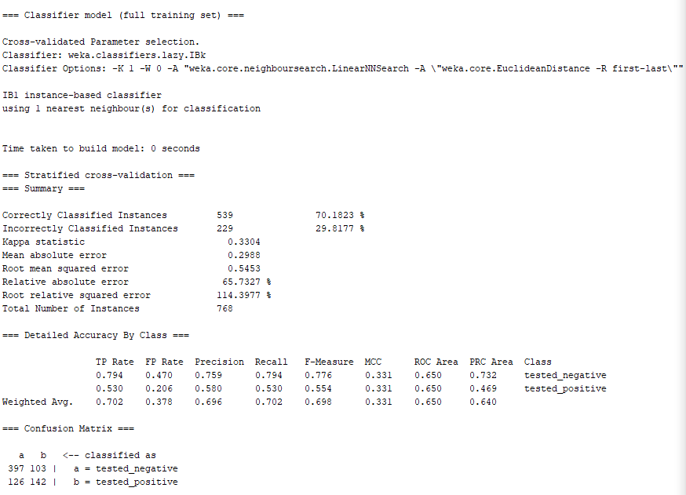
The accuracy is 70.1823% without CV parameter selection.
After CV parameter selection, the accuracy is 73.9583%.
The selected value is K = 7
17.4.13
Optimized:
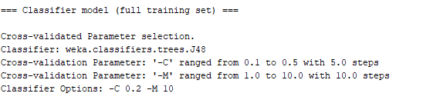
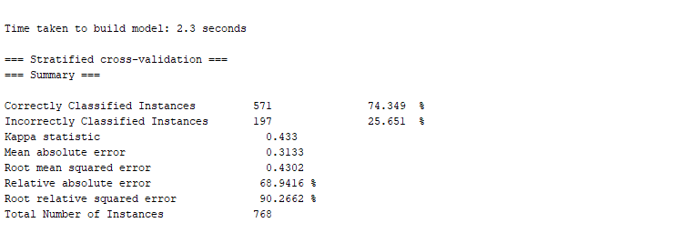
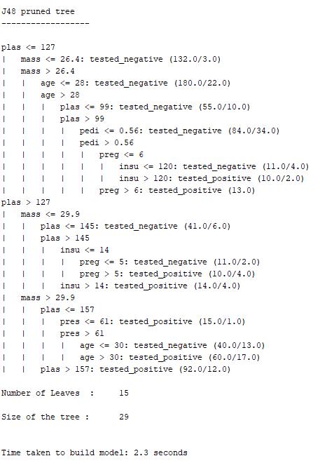
Original:
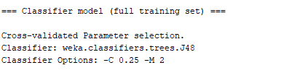
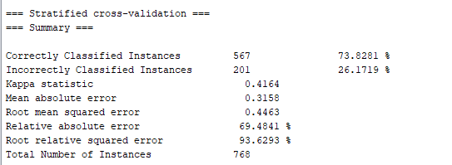
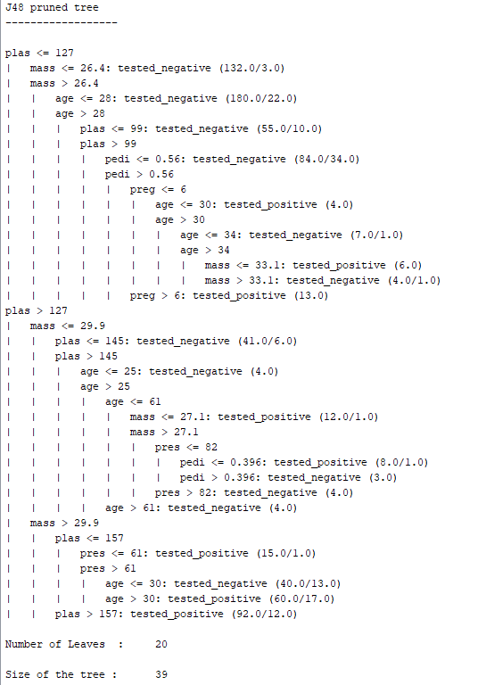
without CV parameter selection:
The accuracy is 73.8281%, the tree size is 39

With CV parameter selection:
The accuracy is 74.349%, the tree size is 29.

The selected value is C = 0.2, M = 10.

4.
17.3.8
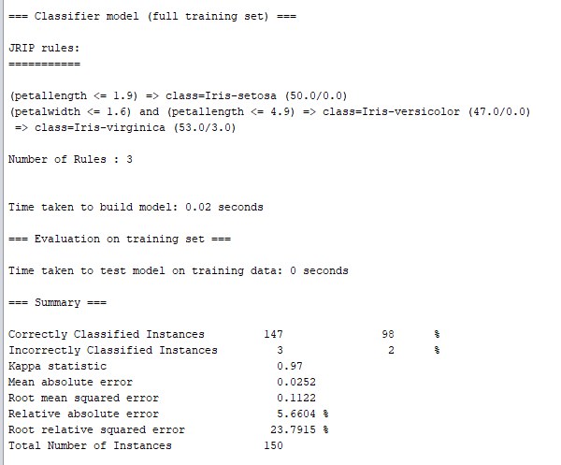
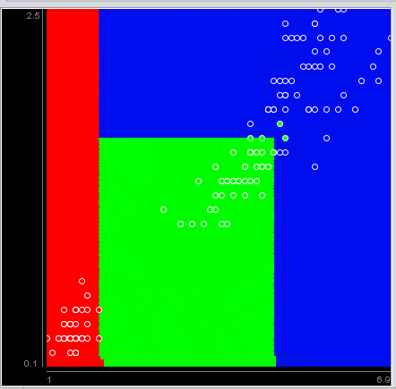
The JRip classify the spot in three types with generate three rules.
17.3.9
petallength <=1.9 =>class=Iris-setosa;
petallength <=4.9 and petallength >1.9 and petalwidth <=1.6 =>class=Iris-versicolor;
petallength >4.9 or petallength <=4.9 and petallength >1.9 and pentallwidth >1.6 => class=Iris-virginica;

17.3.10
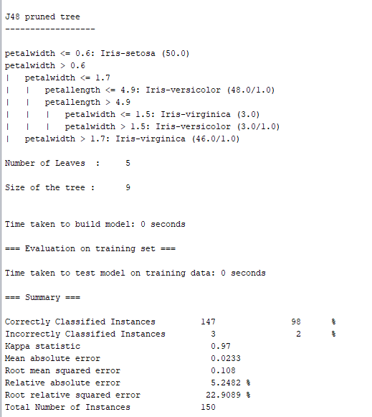

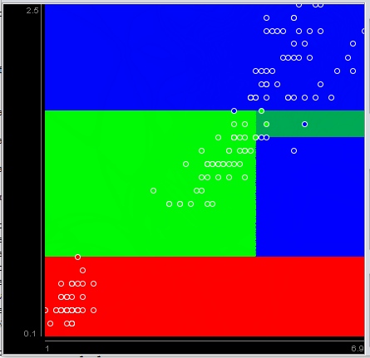

J48 generate a decision tree with 5 leaves to classify the spot.

7.3.11
3: >6 and <50
2: >=50 and <=75
1: >75

17.3.12
When we add some noise, the J48 bound hardly changed, but JRip changed much. So we could say:
J48 has better efficiency to count noise than JRip.
J48 could solve the overfitting better

JRip:
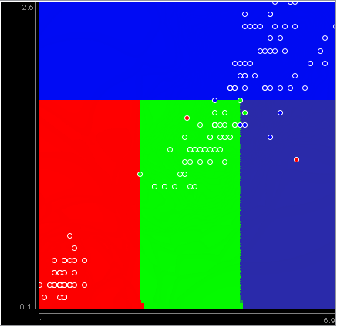

J48:
